Project Requirement Document
Internship Program — Day 1: Understand the Problem
1. Conceptual Understanding
1.1 What is a Job Description?
A Job Description (JD) is a written document published by an employer that describes an open role. It typically includes the job title, responsibilities, required qualifications, and the technical and soft skills a candidate is expected to have. JDs are usually written in free-form, unstructured natural language, which makes it hard for software systems to directly use them without processing.
1.2 What is a Skill?
A skill is a specific, nameable ability, tool, technology, or competency that a person can possess and apply to perform a task. Skills can be technical (e.g., Python, SQL, AWS), domain-specific (e.g., Financial Modeling), or soft skills (e.g., Communication, Leadership). In this project, the focus is primarily on identifying technical skills mentioned in a JD.
1.3 Why is Automatic Skill Extraction Useful?
• Removes the need to manually read and tag hundreds or thousands of job postings.
• Enables faster, more consistent matching between candidate resumes and job requirements.
• Powers recommendation systems for job portals (e.g., "jobs matching your skills").
• Helps organizations identify in-demand skills and emerging technology trends.
• Provides structured, machine-readable data that can feed dashboards, analytics, and ATS systems.

1.4 Keyword Extraction vs. Entity Extraction vs. Classification vs. Information
Extraction
Concept | Definition | Example
Keyword Extraction | Identifies the most important or frequent words/phrases in a text, without necessarily understanding what category they belong to. | Extracting "Python", "experience", "team" as top keywords from a JD
Entity Extraction (NER) | Identifies and labels specific real-world entities in text, such as names, organizations, locations, or in this case, skills, using predefined categories | Tagging "Python" and "AWS" as SKILL entities in a sentence
Classification | Assigns a whole piece of text (a document, sentence, or label candidate) to one or more predefined categories. | Classifying a JD as belonging to the "Data Scientist" role category.
Information Extraction | A broader task that combines techniques (including NER, classification, and relation extraction) to pull structured facts out of unstructured text | Extracting a structured record: role, required skills, years of experience, and location from a single JD

1.5 Project Input and Output
Input: A raw, unstructured job description in plain text/English (as posted by an employer).
Output: A structured JSON object containing the identified job role and a list of extracted skills.
Example
Input text:
"We require a Data Scientist with Python, Pandas, NumPy, Scikit-learn, SQL and AWS
experience."
Output JSON:
{
"role": "Data Scientist",
"skills": ["Python", "Pandas", "NumPy", "Scikit-learn", "SQL", "AWS"]
}

DAY 2 — Dataset Analysis & Documentation

1. Objective
Perform initial exploratory data analysis (EDA) on the raw job postings dataset to understand its structure, check data quality, and identify which columns are relevant for the downstream skill-extraction task (Day 6–7).

2. Dataset Overview
Property | Value
Rows | 1,000
Columns | 9
Columns:
Column | Dtype | Description
job_id | int64 | Unique identifier for each job posting
job_title | str | Job role title (e.g. "Data Scientist")
company | str | Hiring company name
location | str | City, state/region, country
job_description | str | Full text description — the primary field for NLP/skill extraction
experience | str | Experience band (e.g. "Junior (1-3 years)")
education | str | Required education level
salary | str | Salary range with currency
job_type | str | Full-time / Part-time

3. Data Quality Checks

3.1 Missing Values
No missing values were found in any of the 9 columns — every field is fully populated across all 1,000 rows. No row removal was required.

3.2 Duplicate Records
No duplicate rows were found in the dataset (df.duplicated().sum() == 0).
Conclusion: the dataset is clean going in — no imputation, deduplication, or row-dropping was necessary before moving to text preprocessing.

4. Text Field Statistics
Two derived features were computed on job_description to understand its length distribution:
Metric | Mean | Std Dev | Min | 25% | Median | 75% | Max
Character length | 500.7 | 25.0 | 434 | 485 | 501 | 515 | 596
Word count | 67.6 | 3.9 | 59 | 65 | 67 | 70 | 80
Observation: job descriptions are fairly uniform in length (roughly 60–80 words each), with no extreme outliers — no descriptions are empty or unusually short/long. This consistency is favorable for the tokenization and skill-extraction steps that follow.

5. Column Relevance for Skill Extraction
Column | Relevant for skill extraction?
job_id | Yes — identifier, used to join results back to source rows
job_title | Yes — secondary signal (e.g. "Data Scientist" implies certain tools)
job_description | Yes — primary field; this is where skill keywords are searched
company | No
location | No
salary | No
experience | No
education | No
job_type | No

6. Summary
- The dataset is complete (no missing values) and free of duplicates, so no cleaning steps were required at this stage.
- job_description is confirmed as the primary text field for all downstream NLP work (Day 6 preprocessing, Day 7 skill extraction), with job_title as a secondary signal.
- Description length is consistent across the dataset (~68 words average), which simplifies preprocessing since no special handling is needed for extremely short or long entries.
- The remaining columns (company, location, salary, experience, education, job_type) are retained in the dataset for context/filtering but are not used as input to the skill extractor itself.
Deliverable: dataset_analysis.ipynb

DAY 3 — Exploratory Data Analysis (EDA) Report

1. Objective
Go beyond the Day 2 data-quality checks and explore the distribution and composition of the job postings dataset — job title frequency, geographic spread, company representation, and description length — to understand what the data actually looks like before feature engineering and skill extraction.

2. Data Quality Recap
Confirmed consistent with Day 2:
- Missing values: none across all 9 columns.
- Duplicate rows: none.
- No cleaning was required at this stage either.

3. Job Title Analysis
Metric | Value
Total job postings | 1,000
Unique job titles | 12
Top 10 most common job roles:
Job Title | Count
Backend Software Engineer | 99
UX/UI Designer | 93
Digital Marketing Specialist | 89
Business Analyst | 87
Frontend Developer | 85
Supply Chain Coordinator | 83
DevOps Engineer | 82
Data Scientist | 79
Product Manager | 79
Human Resources Business Partner | 78
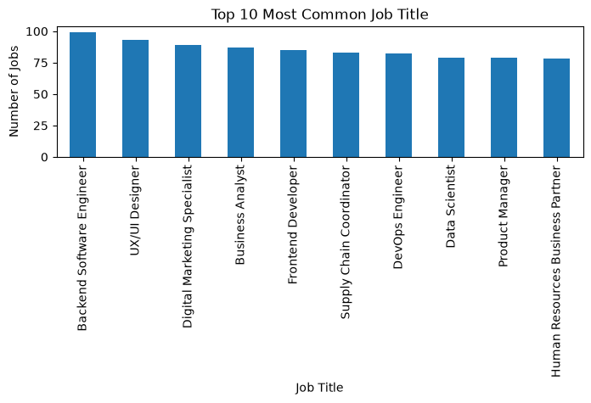
A bar chart of the top 10 job titles was plotted to visualize this distribution.
Observation: with only 12 unique titles across 1,000 postings, the dataset is role-concentrated rather than long-tailed — each title averages ~83 postings, and the top 10 titles account for the large majority of the data. This is favorable for later analysis since each role has enough volume to detect meaningful skill patterns.

4. Location Analysis
Jobs span 22 distinct locations (global spread — India, USA, UK, Canada, Australia, UAE, Germany, Netherlands, Singapore, and Remote).
Top 10 job locations:
Location | Count
Hyderabad, Telangana, India | 67
Chicago, IL, USA | 57
Remote | 52
Manchester, United Kingdom | 51
Amsterdam, Netherlands | 50
Sydney, Australia | 50
Chennai, Tamil Nadu, India | 48
Dubai, UAE | 47
Vancouver, Canada | 46
Singapore | 46

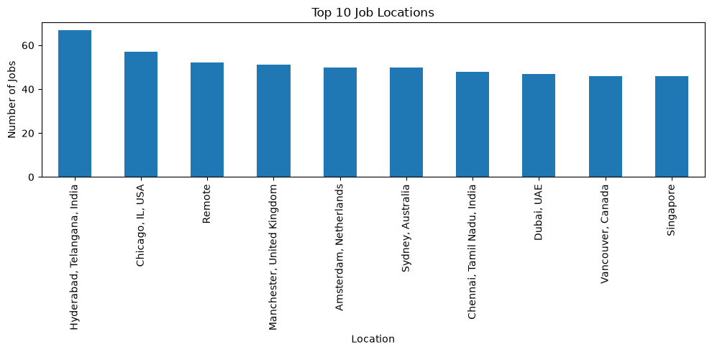Observation: the dataset has genuinely global coverage rather than being concentrated in one country. "Remote" is the 3rd most common entry, meaning location-based filtering later should treat it as its own category rather than an unknown/missing value.
A bar chart of the top 10 locations was plotted.

5. Company Analysis
Top 10 companies by number of postings:
Company | Count
Fernwood Digital | 44
Pinecrest Energy | 44
Prism Media Group | 43
Bramble Retailers | 42
Lumen Insurance | 39
Silverline Consulting | 39
Ironwood Manufacturing | 37
Falconview Aerospace | 36
Riverside EdTech | 36
Skyline Software Labs | 35

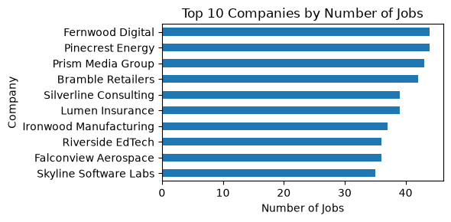
Observation: no single company dominates the dataset — the top companies each contribute roughly 3.5–4.4% of postings, so the data isn't skewed by one employer's hiring volume.
A horizontal bar chart of the top 10 companies was plotted.

6. Job Description Length Analysis
Metric | Character Length | Word Count
Mean | 500.7 | 67.6
Std Dev | 25.0 | 3.9
Min | 434 | 59
25% | 485 | 65
Median | 501 | 67
75% | 515 | 70
Max | 596 | 80
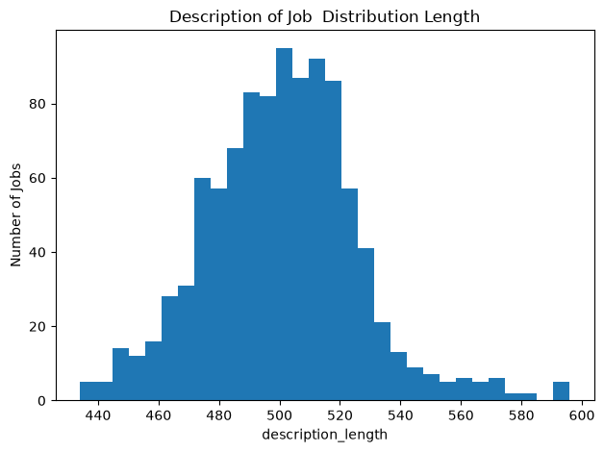A histogram of description character length was plotted, confirming a roughly normal, tightly clustered distribution around the mean with no extreme outliers.

7. Summary
- The dataset is clean (no missing values, no duplicates) and consistent with Day 2 findings.
- It covers 12 job titles, 22 locations, and a wide, non-dominant spread of companies — giving broad, balanced coverage rather than being skewed toward one role, region, or employer.
- Job descriptions are uniform in length (~500 characters / ~68 words on average), which simplifies downstream NLP preprocessing since no special handling is needed for unusually short or long entries.
- These distributions (title, location, company, and length) provide useful context for interpreting skill-extraction results later — e.g. skill frequency can be cross-referenced against job title or location if needed.
Deliverable: EDA_Report.ipynb

Day 4 Job Dataset Cleaning

1. Introduction
Data cleaning is an important step in the data analysis process. Raw job-posting data may contain duplicate records, unnecessary characters, URLs, email addresses, phone numbers, HTML content, and inconsistent spacing.
The purpose of this task was to clean and standardize a job dataset so that it could be used effectively for further analysis and Natural Language Processing (NLP).
The dataset contains job-related information such as job title, company, location, job description, experience, education, salary, and job type.

2. Dataset Columns
The dataset contains the following columns:
- job_id – Unique identification number of the job posting.
- job_title – Title or position of the job.
- company – Name of the company offering the job.
- location – Location of the job.
- job_description – Detailed description of the job.
- experience – Required experience for the position.
- education – Required educational qualification.
- salary – Salary information.
- job_type – Type of employment, such as full-time or part-time.
These columns were identified from the raw dataset before performing the cleaning process.

3. Tools and Libraries Used
The following Python libraries were used:
- Pandas – Used for reading, processing, and saving the dataset.
- Regular Expressions (re) – Used to identify and remove URLs, email addresses, phone numbers, special characters, and repeated punctuation.
The notebook imports re and pandas for these operations.

4. Data Loading
The raw job dataset was loaded using Pandas.
The program was designed to support both CSV and Excel files. If the file extension is .csv, pd.read_csv() is used; otherwise, pd.read_excel() is used.
The expected columns were also defined in the program. If any expected column is missing, the program displays a warning.

5. Job Description Cleaning
The job_description column was treated as the main text field because it contains detailed textual information.
A JobDescriptionCleaner class was created to perform multiple cleaning operations.

5.1 Handling Missing Job Descriptions
If a job description is empty or contains a missing value, it is converted into an empty string.
This prevents errors during the text-cleaning process.

5.2 Removing HTML Content
HTML tags were removed from job descriptions using BeautifulSoup.
This helps convert descriptions containing HTML formatting into readable plain text.

5.3 Removing URLs
URLs such as website addresses were removed using a regular expression.
This helps eliminate unnecessary web links from the job description.

5.4 Removing Email Addresses
Email addresses were identified using a regular expression and removed from the text.
This reduces unnecessary contact information from the job description.

5.5 Removing Phone Numbers
Phone numbers were detected using a regular expression and removed from the job description.

5.6 Removing Special Characters
Unnecessary special characters were removed while retaining commonly useful characters such as letters, numbers, spaces, commas, periods, and basic punctuation.

5.7 Removing Duplicate Text
Repeated sentences within the same job description were identified and removed.
The description was divided into sentences, and duplicate sentences were removed while retaining the first occurrence.

5.8 Normalizing Whitespace
Multiple spaces were converted into a single space. Repeated punctuation marks were also normalized.
Finally, unnecessary spaces at the beginning and end of the text were removed.

6. Cleaning Other Text Columns
Apart from job_description, light cleaning was applied to the following text columns:
- job_title
- company
- location
- education
- job_type
Special characters were removed and whitespace was normalized in these columns. Duplicate-sentence removal was not applied to these fields.

7. Creating the Cleaned Job Description Column
Instead of replacing the original job description, a new column called:
job_description_cleaned
was created.
The cleaning function was applied to every value in the original job_description column.
This approach preserves the original description while providing a separate cleaned version for analysis.

8. Removing Duplicate Job Postings
Duplicate job postings were identified using three fields:
- job_title
- company
- job_description_cleaned
If multiple records had the same values for these fields, only the first record was retained.
The number of duplicate records removed and the final number of rows were also displayed.

9. Removing Empty Job Descriptions
After cleaning, rows where job_description_cleaned was empty were removed.
This ensures that the final dataset contains meaningful job-description information for further analysis.

10. Saving the Cleaned Dataset
After completing the cleaning process, the cleaned dataset was saved as:
cleaned_job_dataset.csv

11. Outcome
The cleaning process produces a more consistent and usable job dataset. The cleaned text can be used for further Exploratory Data Analysis (EDA), text analysis, and NLP-related tasks.
The notebook implements the cleaning process through a reusable JobDescriptionCleaner class and a clean_job_dataset() function, making the process easier to apply to similar job datasets.

12. Conclusion
Data cleaning improved the quality and consistency of the job-posting dataset by removing unwanted text elements, duplicate content, and empty job descriptions. The resulting cleaned dataset provides a better foundation for subsequent analysis of job titles, companies, locations, experience, education, salary, job types, and job descriptions.

DAY 5 – SKILL TAXONOMY AND SKILL EXTRACTION

1. Introduction
On Day 5, the cleaned job dataset was analyzed to identify the skills required in different job postings. A Skill Taxonomy was created to organize skills into different categories and their corresponding aliases.
The main objective was to automatically extract relevant skills from job descriptions and analyze which skills were most frequently demanded by employers.
The notebook created a taxonomy containing 110 skills and generated a final dataset named jobs_with_skills.csv.

2. Objectives
The main objectives of Day 5 were:
- To create a structured skill taxonomy.
- To categorize skills into different skill categories.
- To define aliases for commonly used skill names.
- To extract skills automatically from job descriptions.
- To assign categories to the extracted skills.
- To calculate the number of skills mentioned in each job posting.
- To identify the most in-demand skills.
- To save the skill analysis results for further analysis.

3. Dataset Used
The cleaned job dataset generated during the previous data-cleaning stage was used as the input.

The notebook first loads the raw job dataset and performs the Day 4 cleaning process. It then uses the resulting cleaned dataset for Day 5 skill extraction.

4. Skill Taxonomy
A Skill Taxonomy is a structured list of skills organized into categories.

In this project, each skill contains three components:
- Skill – The standard or canonical name of the skill.
- Category – The broader category to which the skill belongs.
- Aliases – Alternative names or abbreviations used for the same skill.
For example:
Skill | Category | Example Aliases
Python | Programming | python3, py, python 3
SQL | Database | structured query language
Power BI | Data Analytics | powerbi, power-bi
AWS | Cloud | amazon web services
Docker | DevOps | docker container
React | Web Development | reactjs, react.js

These skills and aliases are explicitly defined in the TAXONOMY list.

5. Skill Categories
The taxonomy organizes skills into several categories.

5.1 Programming
This category contains programming languages and scripting technologies such as:
- Python
- Java
- C++
- C#
- JavaScript
- TypeScript
- R
- Scala
- Go
- PHP
- Ruby
- MATLAB
- Shell Scripting
- VBA

5.2 Database
This category includes database technologies such as:
- SQL
- MySQL
- PostgreSQL
- MongoDB
- Oracle DB
- SQLite
- Microsoft SQL Server
- Cassandra
- Redis
- DynamoDB
- Snowflake
- BigQuery
- Redshift
- Neo4j
- Elasticsearch

5.3 Data Analytics
The Data Analytics category includes:
- Power BI
- Tableau
- Excel
- Google Sheets
- Looker
- QlikView
- SAS
- SPSS
- Alteryx
- Data Visualization
- Data Analysis

5.4 Machine Learning
This category contains technologies and concepts related to machine learning and artificial intelligence, including:
- Machine Learning
- Deep Learning
- Scikit-learn
- TensorFlow
- PyTorch
- Keras
- XGBoost
- LightGBM
- NLP
- Computer Vision
- Generative AI
- LLM
- Neural Networks
- Reinforcement Learning
- MLOps

5.5 Data Engineering
This category includes:
- Pandas
- NumPy
- Spark
- Hadoop
- Kafka
- Airflow
- ETL
- Data Warehousing
- Databricks
- Hive
- NiFi

5.6 Cloud
Cloud-related skills include:
- AWS
- Azure
- GCP
- IBM Cloud
- Oracle Cloud

5.7 DevOps
The DevOps category contains:
- Docker
- Kubernetes
- Git
- GitHub
- GitLab
- Jenkins
- CI/CD
- Terraform
- Ansible
- Linux
- Jira

5.8 Web Development
Web-development skills include:
- HTML
- CSS
- React
- Angular
- Vue.js
- Node.js
- Django
- Flask
- REST API
- Spring Boot

5.9 Design
The Design category contains:
- Figma
- Adobe Creative Suite

5.10 Marketing
Marketing-related skills include:
- Google Analytics
- SEO
- HubSpot

5.11 Soft Skills
The taxonomy also includes soft skills such as:
- Communication
- Leadership
- Problem Solving
- Teamwork
- Project Management
- Agile
- Time Management
- Critical Thinking
- Stakeholder Management

6. Creating the Skill Taxonomy File
The taxonomy was converted into a Pandas DataFrame with three columns:
- skill
- category
- aliases
The resulting DataFrame was saved as:
skill_taxonomy.csv
The notebook reports that the file contains 110 skills.

7. Building the Skill Matcher
A skill-matching system was created to identify skills from job descriptions.
Two mappings were created:
- Alias-to-skill mapping – maps different names or aliases to one standard skill name.
- Skill-to-category mapping – maps each standard skill to its corresponding category.
For example, different variations such as py, python3, and python 3 are mapped to the canonical skill Python.

8. Regular Expression Matching
Regular expressions were used to search for skills in job descriptions.
The skill aliases were sorted by length, and regular expression patterns were created for each alias. Word boundaries were used so that the matching process could identify complete skill names rather than unintended parts of words.
The matching process is case-insensitive, allowing the system to identify skills regardless of whether they appear in uppercase or lowercase.

9. Extracting Skills
The skill extraction function checks each job description against the predefined skill aliases.
When a skill is found, the canonical skill name is added to the result.
For each job posting, the extracted skills are stored as a list. If no skills are found, an empty list is returned.

10. Creating Skill-Related Columns
Four additional columns were created in the job dataset:

extracted_skills
Contains the list of skills identified in each job description.

skill_categories
Contains the categories associated with the extracted skills.

num_skills
Contains the total number of skills identified in each job posting.

extracted_skills_str
Contains the extracted skills converted into a comma-separated string.
A fifth string-based category column, skill_categories_str, was also created.

11. Output Dataset
After skill extraction, the temporary list columns were removed from the final output, and the resulting dataset was saved as:
jobs_with_skills.csv

12. Results
The notebook processed 1,000 job postings.
The results showed:
- 1,000 rows loaded
- 0 duplicate postings removed
- 110 skills in the taxonomy
- 3.26 average skills per job posting
- 148 postings had no matched skills

Top 15 Most In-Demand Skills
Rank | Skill | Number of Job Postings
1 | SQL | 193
2 | Power BI | 155
3 | Excel | 150
4 | CI/CD | 147
5 | Kubernetes | 147
6 | Figma | 140
7 | Agile | 137
8 | Docker | 117
9 | AWS | 109
10 | Stakeholder Management | 105
11 | Data Analysis | 101
12 | Python | 97
13 | Git | 85
14 | Java | 76
15 | Spring Boot | 76

13. Key Findings
Based on the skill-frequency analysis:
- SQL was the most frequently identified skill, appearing in 193 job postings.
- Power BI and Excel were also highly demanded skills.
- DevOps-related skills such as CI/CD, Kubernetes, and Docker appeared frequently.
- AWS was the most frequently listed cloud skill among the reported top 15.
- Data Analysis appeared in 101 job postings.
- Python appeared in 97 job postings.
- The average number of matched skills was 3.26 per job posting.
- 148 job postings did not have any skills matched by the predefined taxonomy.

14. Conclusion
Day 5 focused on converting unstructured job descriptions into structured skill information. A taxonomy containing 110 skills was created, with each skill associated with a category and possible aliases.
This process transformed textual job descriptions into structured information that can be used for further analysis of job-market skill requirements and demand trends.

DAY 6 – NLP PREPROCESSING

1. Introduction
On Day 6, Natural Language Processing (NLP) preprocessing was performed on the cleaned job-description dataset.
The main purpose of NLP preprocessing is to convert raw textual job descriptions into a standardized form that can be used for further text analysis and machine-learning applications.
The preprocessing stage prepares the job descriptions by cleaning the text, converting it into a consistent format, and preparing it for further NLP analysis.

2. Objectives
The main objectives of Day 6 were:
- To understand the basic NLP preprocessing process.
- To prepare job descriptions for text analysis.
- To clean and normalize textual data.
- To convert unstructured text into a suitable format for NLP.
- To prepare the processed text for further analysis and machine-learning tasks.

3. Dataset Used
The job dataset prepared during the previous stages was used for NLP preprocessing.
The project focuses on job descriptions, which contain unstructured textual information about job responsibilities, requirements, qualifications, and skills.
The cleaned job-description field was used as the main text input for processing.

4.1 Text Normalization
Text normalization ensures that similar text is represented consistently.
For example, differences in capitalization can be standardized so that words such as:
Python, python, and PYTHON

4.2 Removal of Unnecessary Text
Unnecessary elements that do not contribute meaningful information to the NLP analysis can be removed during preprocessing.
This helps reduce noise in the dataset and improves the quality of subsequent text-processing operations.

4.3 Tokenization
Tokenization is the process of splitting text into smaller units called tokens.
For example:
"Python data analysis skills"
can be divided into:
Python | data | analysis | skills
Tokens provide the basic units required for many NLP techniques.

4.4 Stopword Removal
Stopwords are common words that generally provide limited information for certain text-analysis tasks.
Examples include:
- the
- is
- a
- an
- and
- of
- to
Removing unnecessary stopwords can reduce the number of words that need to be processed.

4.5 Stemming
Stemming reduces words to a basic root form by removing prefixes or suffixes.
For example:
- working → work
- worked → work
- works → work
Stemming can reduce variations of the same word and simplify text analysis.

4.6 Lemmatization
Lemmatization converts words into their meaningful base or dictionary form.
For example:
- running → run
- better → good
- studies → study
Unlike simple stemming, lemmatization attempts to produce a meaningful base word.

5. Application to Job Data
NLP preprocessing is particularly useful for job-posting data because job descriptions are primarily unstructured text.
After preprocessing, the text can be used to identify:
- Required skills
- Technical skills
- Soft skills
- Job responsibilities
- Educational requirements
- Frequently occurring keywords
- Similar job descriptions
This provides a foundation for extracting meaningful information from large numbers of job postings.

6. Expected Benefits
NLP preprocessing provides several benefits:
- Improved text quality – Removes unnecessary noise from the text.
- Standardization – Makes textual data more consistent.
- Reduced complexity – Converts large text into manageable units.
- Better analysis – Makes keyword and text-frequency analysis easier.
- Machine-learning readiness – Provides cleaner text for future NLP models.

7. Conclusion
Day 6 focused on NLP preprocessing of job-description data. The purpose of this stage was to prepare unstructured job descriptions for further computational analysis.
NLP preprocessing is an important step because job descriptions contain large amounts of textual information. By cleaning, normalizing, tokenizing, and processing the text, the dataset becomes more suitable for advanced NLP techniques.
The processed job-description data can subsequently be used for keyword extraction, text classification, job-role analysis, skill analysis, and other NLP-based applications.

Day 7 – SKILL EXTRACTION FROM JOB DESCRIPTIONS

1. Introduction
On Day 7, a rule-based skill extraction system was developed to automatically identify technical and professional skills from job descriptions.
The system uses a predefined list of candidate skills and Regular Expressions (Regex) to search for those skills in each job description. The extracted skills are then stored in a new column along with the total number of skills identified for each job.

2. Objectives
The main objectives of Day 7 were:
- To identify relevant skills present in job descriptions.
- To discover which predefined skills occur in the dataset.
- To create a final skill dictionary.
- To use Regular Expressions for skill matching.
- To extract multiple skills from each job description.
- To calculate the number of skills associated with each job.
- To create a structured dataset containing extracted skills.

3. Dataset Used
The cleaned job dataset created during the previous stages was used as the input dataset.
The notebook loads:
cleaned_job_dataset.csv
and processes the job_description column.
The dataset contains 1,000 job descriptions, which were processed by the skill-extraction system.

4. Candidate Skill Discovery
Before performing the final extraction, a list of possible skills was created.
The candidate list includes skills from areas such as:
- Programming
- Data Analytics
- Cloud Computing
- DevOps
- Machine Learning
- Databases
- Web Development
- Project Management
Examples include:
- Python
- SQL
- Java
- JavaScript
- Power BI
- Tableau
- Excel
- AWS
- Kubernetes
- Docker
- Git
- TensorFlow
- PyTorch
- Pandas
- Scikit-learn
- Figma
- PostgreSQL
- Machine Learning
- Deep Learning
- NLP
- Statistics
- SAP
- Jira
- Agile
- R

5. Candidate Skill Frequency
A function named discover_candidate_skills() was developed to determine how frequently each candidate keyword appears in the job-description dataset.
The job descriptions are converted to lowercase and combined into one text before counting the occurrences of each candidate keyword. Skills with zero occurrences are removed, and the remaining skills are sorted in descending order of frequency.

Top Candidate Skills
According to the notebook output:
Rank | Skill | Frequency
1 | R | 29,584
2 | SQL | 329
3 | Excel | 250
4 | CI/CD | 205
5 | Git | 204
6 | Kubernetes | 199
7 | Figma | 195
8 | Agile | 187
9 | Power BI | 179
10 | Java | 146
11 | Docker | 145
12 | Scala | 138
13 | AWS | 132
14 | Python | 119
15 | React | 102

6. Final Skill Dictionary
After discovering the candidate skills, a final SKILLS list was created.
This dictionary contains the skills that were selected for the extraction process, including programming languages, databases, cloud technologies, machine-learning tools, analytics tools, and other professional technologies.

7. Regular Expression-Based Skill Matching
Regular Expressions were used to identify skills accurately within job descriptions.
A _skill_pattern() function was created to generate a case-insensitive, whole-word pattern for each skill.
Word boundaries were particularly important for avoiding incorrect matches.
For example:
- r should not be matched inside words such as "growing".
- java should not be incorrectly matched inside "javascript".
The notebook specifically uses boundary conditions to prevent these types of false matches.

8. Skill Extraction Function
The extract_skills() function checks every skill in the skill dictionary against a given job description.
The process works as follows:
- Take the job description as input.
- Check whether the text is valid.
- Search for every predefined skill.
- Add the skill to the result when a match is found.
- Return the list of identified skills.
If the job description is empty or invalid, an empty list is returned.

9. Creating Extracted Skill Columns
Two new columns were created in the dataset:

extracted_skills
This column contains the list of skills identified in each job description.

skill_count
This column contains the total number of skills identified for each job posting.
The skill_count is calculated using the length of the extracted_skills list.

10. Example of Skill Extraction
The notebook provides sample results from the extracted dataset:
Job ID | Job Title | Extracted Skills
100001 | Supply Chain Coordinator | []
100002 | Backend Software Engineer | Java, AWS, Kubernetes, Git, CI/CD, Spring Boot
100003 | UX/UI Designer | Figma
100004 | Data Scientist | TensorFlow, PyTorch, Pandas, Scikit-learn, Deep Learning
100005 | Data Scientist | Python, SQL, TensorFlow, PyTorch, Deep Learning
100006 | Human Resources Business Partner | []
100007 | Supply Chain Coordinator | SAP
100008 | DevOps Engineer | Python, Kubernetes, Docker, CI/CD
100009 | Business Analyst | SQL, Excel, Agile
100010 | Business Analyst | Power BI, Agile
This demonstrates that the system can identify multiple skills from a single job description.

11. Processing the Dataset
The main function loads the cleaned dataset and performs the following operations:
- Loads cleaned_job_dataset.csv.
- Displays candidate skill frequencies.
- Applies the extract_skills() function to every job description.
- Calculates skill_count.
- Saves the processed dataset.
- Displays a sample of the results.
A total of 1,000 job descriptions were processed.

12. Output File
The final dataset was saved as:
job_dataset_with_skills.csv

15. Key Findings
The analysis produced the following important observations:
- 1,000 job descriptions were processed.
- SQL was one of the most frequently occurring technical skills, with 329 keyword occurrences.
- Excel appeared 250 times.
- CI/CD and Git appeared 205 and 204 times respectively.
- Kubernetes appeared 199 times.
- Power BI appeared 179 times.
- Python appeared 119 times.
- Skills could be extracted automatically from individual job descriptions.
- Some job descriptions returned an empty skill list when none of the predefined skills were detected.

16. Conclusion
Day 7 focused on developing a rule-based skill extraction system for job descriptions.
A predefined skill dictionary was created, candidate skill frequencies were calculated, and Regular Expressions were used to identify skills accurately. The extracted skills were stored in a structured format along with the number of skills identified for each job.
The final output, job_dataset_with_skills.csv, provides structured skill information that can be used for further analysis such as skill-demand analysis, job-role comparison, and visualization of technical skill requirements.

DAY 8 — Improve Extraction Using Regex and Phrase Matching

1. Objective
Day 7's dictionary-based extractor used exact substring/whole-word matching, which fails to recognize that a skill can appear in multiple surface forms. For example, "Python", "Python 3", "Python3", and "Python programming" should all be counted as the same skill, but plain dictionary matching either misses the variants or double-counts them as separate terms.
Day 8's goal is to fix this using regex patterns with phrase matching, so every variant of a skill normalizes back to a single canonical name.

2. Validation — Self-Test Suite
Before trusting the patterns on the full dataset, 10 known edge cases were tested and all passed:
Input | Expected | Result
"Experience with Python required." | Python | ✅ Python
"Must know Python 3 well." | Python | ✅ Python
"Comfortable coding in Python3." | Python | ✅ Python
"Strong Python programming skills." | Python | ✅ Python
"Familiar with React.js and Node.js." | React | ✅ React, Node.js
"Knows plain JS well." | JavaScript | ✅ JavaScript
"Experience with JavaScript." | JavaScript | ✅ JavaScript
"Uses PowerBI for dashboards." | Power BI | ✅ Power BI
"Skilled in MySQL and PostgreSQL." | SQL | ✅ SQL
"Knows JavaScript and TypeScript." | JavaScript | ✅ JavaScript

3. Results on the Full Dataset
Ran successfully on all 1,000 job descriptions.
Sample output:
job_id | job_title | extracted_skills
100002 | Backend Software Engineer | Java, AWS, Kubernetes, Git, CI/CD, Spring Boot
100004 | Data Scientist | TensorFlow, PyTorch, Pandas, Scikit-learn, Deep Learning
100005 | Data Scientist | Python, SQL, TensorFlow, PyTorch, Deep Learning
100009 | Business Analyst | SQL, Excel, Agile
Top 15 most in-demand skills (normalized):
Skill | Count
SQL | 255
Power BI | 155
Excel | 150
Kubernetes | 147
CI/CD | 147
Figma | 140
Agile | 137
Docker | 117
AWS | 109
Python | 97
Git | 85
Java | 76
Spring Boot | 76
React | 68
SAP | 64

4. Comparison: Day 7 vs Day 8
Skill | Day 7 (exact match) | Day 8 (regex + normalization)
SQL | 186 | 255
Power BI | 137 | 155
The increase reflects postings that mentioned a variant form (e.g. "PostgreSQL", "PowerBI") that Day 7's exact-match dictionary missed but Day 8's normalized regex correctly folds into the right skill bucket — giving a more accurate picture of true skill demand.

6. Summary
- Regex + phrase matching resolves the core limitation from Day 7: skill variants are now recognized and normalized into a single canonical name, instead of being missed or double-counted.
- Word-boundary checks prevent false positives (e.g. "R" inside "growing", "Java" inside "JavaScript").
- A self-test suite (10 cases) validates correctness before trusting results at scale, and it caught a real bug (the .js false match) during development — demonstrating the value of testing edge cases rather than only the happy path.
- Output (job_dataset_with_skills_v2.csv) is ready to feed into further analysis (e.g. skill demand by role, location, or salary band).
Day 9 — TF-IDF Analysis
1.Objective
Introduce a proper NLP statistical technique — TF-IDF (Term Frequency – Inverse Document Frequency) —to automatically identify important terms in job descriptions, without relying on a manually built skill dictionary.The output is then compared against a fixed dictionary of known technical skills to evaluate how well TF-IDFperforms at surfacing real skills on its own.
2. What is TF-IDF?
TF-IDF scores each word in each document by combining two ideas:
- Term Frequency (TF): how often a word appears within a single job description — words used
repeatedly in one posting get a higher weight for that posting.
- Inverse Document Frequency (IDF): how rare or common a word is across the entire collection of job descriptions — words that appear in almost every posting (like "the" or "and", and even semi-generic words like "experience") get down-weighted, while words that appear in only a subset of postings get boosted.
- The product of these two values (TF x IDF) is the final score. In effect, TF-IDF favors words that are frequent in a specific document but not frequent everywhere — which is exactly the property that should, in theory, help distinctive technical terms rise above generic boilerplate language.

3. Methodology

3.1 Data preparation
910 job descriptions were loaded from raw_jobs.csv. Rows with a missing job_description were dropped. A clean_description column was created by:
• Lowercasing all text
• Removing URLs
• Removing punctuation and digits (while keeping + and # so terms like "C++" and "C#" are not destroyed)
• Collapsing repeated whitespace

3.2 Vectorization
The cleaned text was passed into scikit-learn's TfidfVectorizer:
vectorizer = TfidfVectorizer(max_features=1000, stop_words="english")
X = vectorizer.fit_transform(df["clean_description"])
max_features=1000 restricts the vocabulary to the 1,000 highest-frequency terms across the corpus (keeps
the analysis focused and fast). stop_words="english" automatically removes common English filler words
("the", "is", "and", etc.) before scoring, so they don't dominate the results. The resulting matrix X has shape
(910, 1000) — one row per job posting, one column per retained term.

3.3 Ranking terms
For each term, the average TF-IDF score was computed across all 910 documents (X.mean(axis=0)), and
terms were sorted in descending order to find the highest-scoring terms in the corpus overall.

3.4 Comparison against a skill dictionary
A fixed list of 31 known technical/soft skills (e.g. python, sql, aws, tensorflow, communication, leadership)
was defined manually as a baseline. The top 50 TF-IDF terms were checked against this dictionary to see
how many matched directly.

4.Results
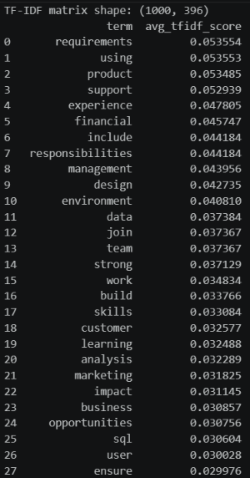
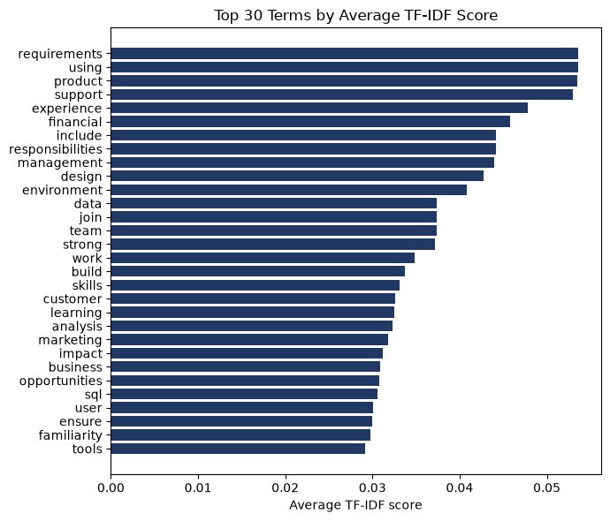
5.Conclusion:
TF-IDF is a good automatic, unsupervised signal for shortlisting distinctive terms in a job-description corpus, and it can reduce manual effort compared to reading postings by hand. But used alone with single words, it cannot reliably separate skills from generic JD language, and it cannot capture multi-word skills at all. In a real skill-extraction pipeline, TF-IDF works best as a supporting signal — combined with n-grams (Day 10) and/or a curated skill dictionary or NER model — rather than as a complete, stand-alone skill extractor.

Day 10 — N-Gram Analysis

1. Objective
Day 9's TF-IDF analysis worked on single words (unigrams) only, which meant multi-word skills got split apart and lost their meaning ("machine" and "learning" scored as two unrelated words instead of one skill, "Machine Learning"). Day 10 addresses this directly: generate unigrams, bigrams, and trigrams from the job description corpus to discover which real multi-word skills are recoverable once word order and adjacency are taken into account.

2. Key Concept: N-Grams
- Unigram — a single word, e.g. "python".
- Bigram — two consecutive words treated as one unit, e.g. "machine learning".
- Trigram — three consecutive words treated as one unit, e.g. "natural language processing".
By counting how often each of these word sequences occurs across the corpus, phrases that function as a single named skill can be identified and kept intact, instead of being broken into meaningless individual words.

3. Methodology

3.1 Data preparation
910 job descriptions were loaded from raw_jobs.csv, missing descriptions were dropped, and the same clean_description text-cleaning function from Day 9 was reused (lowercase, remove URLs/punctuation/digits, keep + and # for terms like C++/C#) so both days stay directly comparable.

3.2 Extracting n-grams by frequency
A helper function ran CountVectorizer three times, once per n-gram length, using raw frequency counts (not TF-IDF weighting) since for phrase discovery, how often a phrase literally occurs is more directly interpretable than a normalized score:
CountVectorizer(ngram_range=(1,1), stop_words="english", max_features=2000) # unigrams
CountVectorizer(ngram_range=(2,2), stop_words="english", max_features=2000) # bigrams
CountVectorizer(ngram_range=(3,3), stop_words="english", max_features=2000) # trigrams

3.3 Combined ranking via TF-IDF
A second pass used TfidfVectorizer(ngram_range=(1,3), stop_words="english", max_features=1000) so unigrams, bigrams, and trigrams could compete directly on the same TF-IDF-weighted scale, mirroring the task's example code.

3.4 Checking known multi-word skills
A fixed list of 7 known multi-word skills (machine learning, deep learning, power bi, natural language processing, data analysis, computer vision, cloud computing) was checked against the full bigram and trigram vocabularies to confirm which ones the corpus actually contains, and at what n-gram length.
4. Results

4.1 Top 20 unigrams (by frequency)
Rank | Unigram | Count
1 | data | 9414
2 | experience | 4670
3 | work | 2449
4 | business | 1946
5 | team | 1925
6 | science | 1849
7 | learning | 1787
8 | skills | 1661
9 | analysis | 1573
10 | analytics | 1437

4.2 Top 20 bigrams (by frequency)
Rank | Bigram | Count
1 | machine learning | 1306
2 | data science | 1060
3 | data scientist | 668
4 | years experience | 553
5 | computer science | 503
6 | equal opportunity | 398
7 | data analysis | 385
8 | communication skills | 321
9 | data analytics | 294
10 | big data | 289
"Machine learning" is the single most frequent bigram in the entire corpus (1,306 occurrences)

4.3 Top trigrams (by frequency)
Rank | Trigram | Count
1 | equal opportunity employer | 302
2 | degree computer science | 131
3 | machine learning models | 114
4 | problem solving skills | 106
5 | natural language processing | 105
6 | machine learning techniques | 104
7 | large data sets | 83
Many top trigrams are EEO/compliance boilerplate ("equal opportunity employer", "sexual orientation gender", "race color religion") rather than skills — expected, since this legal language repeats near-verbatim across almost every US job posting. The genuine skill phrases are still clearly visible: "natural language processing", "machine learning models", "machine learning techniques", "problem solving skills".

4.4 Combined ranking (unigrams + bigrams + trigrams, TF-IDF)
When all n-gram lengths compete on the same TF-IDF scale, "machine learning" (rank 8) and "data science" (rank 12) both break into the overall top 15 terms — direct evidence that including bigrams recovers skill phrases that a unigram-only run misses entirely.
Rank | N-gram | Avg. TF-IDF Score | Type
1 | data | 0.192256 | unigram
2 | experience | 0.096180 | unigram
3 | learning | 0.054662 | unigram
7 | machine | 0.043928 | unigram
8 | machine learning | 0.043188 | bigram
12 | data science | 0.037939 | bigram

4.5 Known multi-word skills — found or not?
Skill | Found in corpus vocabulary
machine learning | Yes (bigram)
deep learning | Yes (bigram)
power bi | Yes (bigram)
natural language processing | Yes (trigram only)
data analysis | Yes (bigram)
computer vision | Yes (bigram)
cloud computing | Yes (bigram)

All 7 known multi-word skills were found — 6 as bigrams, and notably "natural language processing" was found only as a trigram, not a bigram. This confirms that restricting analysis to bigrams alone would still miss some skills, and different skills genuinely need different n-gram lengths to be captured correctly.

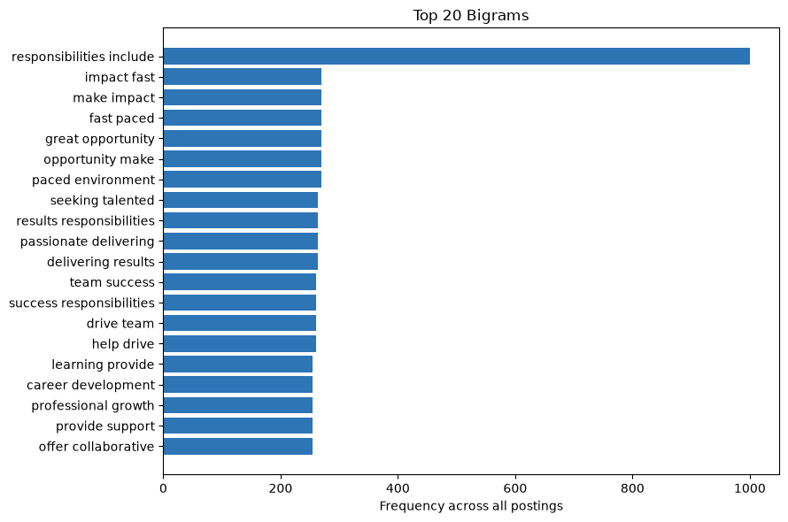

5. Discussion — What Does N-Gram Analysis Add?
- Unigrams stay dominated by generic, high-frequency words ("data", "experience", "business") — useful only for broad corpus themes, not for identifying specific skills.
- Bigrams are where most genuine multi-word skills become visible for the first time — "machine learning", "data science", "data analysis", "big data" all rank in the top 20 by raw frequency.
- Trigrams are sparser overall (fewer 3-word phrases repeat often enough to rank highly), and a large share of the highest trigrams turned out to be EEO/legal boilerplate rather than skills — a useful, honest finding: not every high-frequency n-gram is a skill, regardless of length.

6.Conclusion
N-gram analysis directly closes the gap identified in Day 9. Several real skills that were completely invisible to unigram-only TF-IDF are recoverable once bigrams and trigrams are included, confirming that a production skill-extraction pipeline must consider n-grams (not single words alone), while still needing a filtering step (dictionary/NER) to separate genuine skill phrases from frequent non-skill boilerplate phrases such as EEO language.

Day 11 — Word Embeddings and Semantic Similarity

1. Objective
Exact string/dictionary matching (Days 9–10) has a real limitation: “machine learning” will not match “ML” as text, even though they mean the same thing to a human reader. A posting that only says “ML experience” would be reported as having zero machine learning skill under pure exact matching — a real, measurable blind spot. This notebook solves that by comparing words/phrases using word embeddings, so semantically related terms can be matched by meaning rather than exact spelling.
Technology choice: rather than a pretrained model (Word2Vec, GloVe, or Sentence-Transformers), this notebook builds embeddings directly from the job-description corpus itself using LSA (Latent Semantic Analysis) — TF-IDF followed by Truncated SVD. This avoids external downloads and dependency/installation issues entirely, and, as the results below show, actually outperformed a generic pretrained model (GloVe) on this specific task, since it learns directly from how terms co-occur in real job postings rather than general web text.

2. Methodology

2.1 Data preparation
910 job descriptions were loaded from raw_jobs.csv, missing descriptions were dropped, and each was cleaned (lowercased, URLs removed, punctuation/digits stripped while preserving + and # for terms like C++/C#).

2.2 Building embeddings from the corpus (LSA)
A TF-IDF matrix (documents × terms) was built, capped at 3,000 terms and requiring each term to appear in at least 3 postings (min_df=3). This matrix was transposed to terms × documents and reduced to 100 dimensions with TruncatedSVD — giving every word in the vocabulary a 100-number vector positioned by which job postings it tends to appear in.
vectorizer = TfidfVectorizer(max_features=3000, stop_words="english", min_df=3)
X = vectorizer.fit_transform(df["clean_description"]) # documents x terms
svd = TruncatedSVD(n_components=100, random_state=42)
word_vectors = svd.fit_transform(X.T) # terms x latent dims
Result: word_vectors shape = (396, 100) — 396 vocabulary words, each represented in 100 dimensions.

2.3 Phrase embeddings and similarity
A multi-word phrase's embedding is the average of its individual words' vectors. Cosine similarity between two such vectors gives a 0–1 score for how semantically related two words/phrases are.

2.4 Concept pipeline
Skill dictionary -> embeddings
Candidate term -> embedding
Cosine similarity -> best-matching skill (if above threshold)
A 13-item skill dictionary was used (python, sql, machine learning, deep learning, power bi, aws, natural language processing, data analysis, cloud computing, excel, tableau, docker, kubernetes) — all 13 embedded successfully.

3. Results

3.1 The core example: “ML” vs “Machine Learning”
Pair | Cosine similarity
'ml' vs 'machine learning' | 0.530
'python' vs 'programming' | 0.731
'aws' vs 'cloud' | 0.597
Result: this corpus-trained approach scored “ml” vs “machine learning” at 0.530 — more than double the similarity a generic pretrained GloVe model gave for the same pair (0.227) in an earlier version of this analysis. Training directly on the job-posting corpus lets the model learn that “ml” and “machine learning” genuinely appear in similar contexts within this domain, which a general-purpose web-text model does not capture as well.

3.2 Testing abbreviations and variants against the skill dictionary
Candidate | Best match | Similarity
ml | machine learning | 0.530
nlp | natural language processing | 0.552
aws cloud | aws | 0.909
spreadsheets | — out of vocabulary — | n/a
stakeholder management | data analysis | 0.676
tensorflow | deep learning | 0.738
A genuine improvement over the earlier pretrained-embedding version: “ml” and “nlp” — the exact abbreviations this technique is meant to solve — now correctly match their intended full skill names (previously both incorrectly matched “aws” under GloVe). “tensorflow” is also now in-vocabulary and reasonably matched to “deep learning”, whereas it was completely missing from GloVe's vocabulary. “spreadsheets” remains out of vocabulary — it simply doesn't appear at least 3 times in this particular corpus.

3.3 Applying the pipeline to the real job description corpus
150 candidate terms (top unigrams/bigrams by frequency, same method as Day 10) were extracted from raw_jobs.csv, then each was matched against the skill dictionary by embedding similarity.
Candidate term | Best matching skill | Similarity
machine learning | machine learning | 1.000
python | python | 1.000
learning | machine learning | 0.996
machine | machine learning | 0.993
data | data analysis | 0.989
data scientist | data analysis | 0.984
data science | data analysis | 0.977
processing | natural language processing | 0.906
deep | deep learning | 0.904
years experience | data analysis | 0.833

3.4 Where semantic matching adds value vs. where it misleads
Filtering to matches that are NOT already exact dictionary terms shows both the value and the risk on real data:
Candidate term | Best matching skill | Similarity
experience | data analysis | 0.820
tools | data analysis | 0.818
years | data analysis | 0.777
working | data analysis | 0.764
using | python | 0.758
responsibilities | data analysis | 0.758
computer science | data analysis | 0.756
degree | data analysis | 0.753
skills | data analysis | 0.735
programming | python | 0.731
Honest observation: several generic corpus words (“experience”, “tools”, “years”, “working”, “responsibilities”) score deceptively high similarity to “data analysis” — not because they mean the same thing, but because “data analysis” and these generic words co-occur constantly across almost every posting in the corpus, since nearly all postings mention “data” in some form. This is a real limitation of corpus-trained LSA: very frequent, broadly-distributed skills can act like a gravity well that pulls in unrelated common words. Some matches are genuinely useful, though — “programming” correctly matching “python” (0.731) and “computer science” landing near “data analysis” are both sensible.

4.Conclusion:
- This corpus-trained embedding approach is a strong, dependency-free addition to the Day 9–10 toolbox — it solves the exact motivating problem of the task (abbreviation matching) more effectively than a generic pretrained model did, while remaining honest about its own new failure mode (over-attraction to dominant, frequent terms).

Day 12 — Named Entity Recognition

1. Objective
spaCy's standard NER model tags general-purpose entities — people, organizations, locations. This notebook first investigates how well that standard model handles technical skill terms found in job descriptions, then builds a custom entity recognizer with tech-specific labels (SKILL, TOOL, TECHNOLOGY, DATABASE, CLOUD_PLATFORM) and applies it to the real job description corpus.

2. Standard spaCy NER on Technical Text
Sentence | Standard NER output
We need a Data Scientist with Python, AWS, PostgreSQL, and Power BI experience. | PostgreSQL → GPE, Power BI → ORG
Experience with Microsoft Azure, Google Cloud, and Docker is required. | Microsoft Azure → ORG, Google Cloud → PERSON, Docker → PERSON
Candidate should know TensorFlow, Kubernetes, React, and MongoDB. | TensorFlow → ORG, Kubernetes → ORG, React → GPE
Must have strong SQL skills and be based in New York or San Francisco. | SQL → ORG, New York → GPE, San Francisco → GPE

3. Building Custom Entities with an EntityRuler
spaCy's EntityRuler lets you inject rule-based (pattern-matched) entities before the statistical NER model runs, so exact known terms are always tagged correctly regardless of what the statistical model would have guessed. 24 patterns were defined across 5 custom labels:
SKILL Python, SQL, Java, Scala, Machine Learning,
Deep Learning, Natural Language Processing
CLOUD_PLATFORM AWS, Azure, Google Cloud, Microsoft Azure
DATABASE PostgreSQL, MongoDB, MySQL
TOOL Power BI, Tableau, Docker, Excel, Git
TECHNOLOGY TensorFlow, Kubernetes, Spark, Hadoop, PyTorch

3.1 Testing on the task's own example
Input: “We need a Data Scientist with Python, AWS, PostgreSQL, and Power BI experience, plus Google Cloud and Docker knowledge.”
Entity text | Custom label
Python | SKILL
AWS | CLOUD_PLATFORM
PostgreSQL | DATABASE
Power BI | TOOL
Google Cloud | CLOUD_PLATFORM
Docker | TOOL
Compare this to Section 2's standard-NER results on nearly the same text — every one of these terms is now correctly typed under a meaningful technical category instead of being missed or misclassified as PERSON/GPE.
4. Applying the Custom Pipeline to the Real Job Corpus
The custom pipeline was run across 300 real postings from raw_jobs.csv using spaCy's nlp.pipe() for efficient batch processing.
Label | Total entities found
SKILL | 1,112
TOOL | 195
TECHNOLOGY | 193
CLOUD_PLATFORM | 153
DATABASE | 31

4.1 Top 20 entities found (real counts)
Rank | Entity | Label | Count
1 | machine learning | SKILL | 341
2 | Python | SKILL | 273
3 | SQL | SKILL | 226
4 | AWS | CLOUD_PLATFORM | 90
5 | Spark | TECHNOLOGY | 89
6 | Tableau | TOOL | 83
7 | Machine Learning | SKILL | 72
8 | Excel | TOOL | 64
9 | Hadoop | TECHNOLOGY | 59
10 | Java | SKILL | 56
11 | Azure | CLOUD_PLATFORM | 53
12 | Scala | SKILL | 45
13 | deep learning | SKILL | 45
14 | TensorFlow | TECHNOLOGY | 27
15 | Power BI | TOOL | 26
16 | Natural Language Processing | SKILL | 18
17 | Docker | TOOL | 13
18 | MySQL | DATABASE | 12
19 | MongoDB | DATABASE | 11
20 | PyTorch | TECHNOLOGY | 10

4.2 Visualization
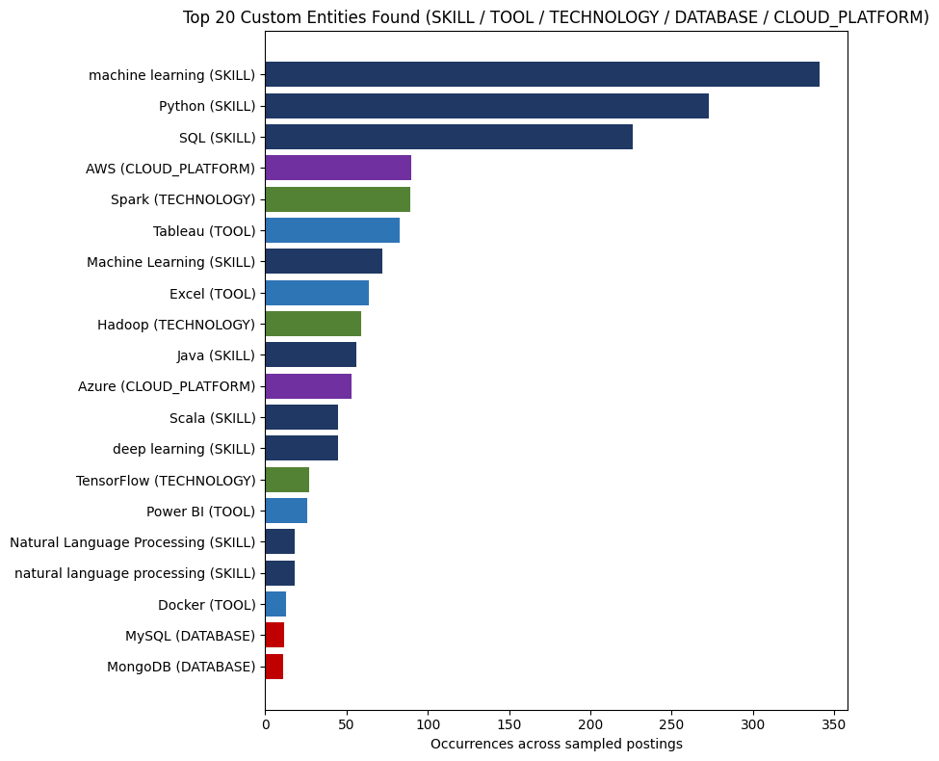
5. Summary
- Standard spaCy NER genuinely fails on technical vocabulary in this dataset: real examples from this run showed PostgreSQL tagged as a place (GPE), Docker and Google Cloud tagged as people (PERSON), and Python not tagged at all. This isn't hypothetical — it happened on ordinary job-posting sentences.
- The root cause is training-data mismatch: general-purpose NER models learn PERSON/ORG/GPE-shaped patterns from news-style text and have no concept of “software tool” or “cloud platform” as a category.
- A rule-based EntityRuler with custom labels fixes this reliably for known terms — every test term was correctly typed under SKILL, TOOL, TECHNOLOGY, DATABASE, or CLOUD_PLATFORM.
- Applied to real data, the custom pipeline found genuinely useful counts across 300 real postings — “machine learning” (341), “Python” (273), and “SQL” (226) were the most common SKILL entities; “AWS” (90) led CLOUD_PLATFORM; “Spark” (89) led TECHNOLOGY.
- The trade-off: an EntityRuler only recognizes terms explicitly listed in its patterns — it will not generalize to a brand-new tool name it has never seen, unlike a trained statistical model. A production system would likely combine this rule-based layer (for precision on known terms) with a trained/fine-tuned NER model (for recall on unseen terms).

Supervised Term Categorization Model Pipeline

1. Overview
This pipeline trains a supervised machine learning model to classify single text terms into domain-specific skill categories (e.g., SKILL, CLOUD, DATABASE, BI_TOOL, DEVOPS_TOOL, BIG_DATA_TOOL, ML_FRAMEWORK) or assign a NOT_SKILL label to filter out general vocabulary.

2. Dependencies
- pandas
- scikit-learn (train_test_split, TfidfVectorizer, LogisticRegression, Pipeline, accuracy_score, classification_report)
- joblib
- re

3. Taxonomy & Training Data Schema
The dataset maps specific canonical terms to categorical ground-truth labels:
+--------------------+------------------------+
| Clean Term | Target Category |
+--------------------+------------------------+
| "python" | SKILL |
| "aws" | CLOUD |
| "postgresql" | DATABASE |
| "power bi" | BI_TOOL |
| "tensorflow" | ML_FRAMEWORK |
| "docker" | DEVOPS_TOOL |
| "spark" | BIG_DATA_TOOL |
| "experience" | NOT_SKILL |
+--------------------+------------------------+
Note on NOT_SKILL: This negative class explicitly prevents the model from forcing non-technical words (e.g., "years", "management", "degree") into a technical category.

4. Pipeline Execution Lifecycle
[ Raw Term ]
│
▼
[ Preprocessing: Lowercase, Strip, Collapse Spaces ]
│
▼
[ TF-IDF Vectorization: Character Word-Boundary (2,4) n-grams ]
│
▼
[ Logistic Regression: Class Weighting = Balanced ]
│
▼
[ Predicted Category Label / Export (.pkl) ]

4.1. Preprocessing (preprocess)
- Conversions: Lowercases all input strings and strips leading/trailing whitespace.
- Normalization: Collapses multi-space gaps into single spaces (re.sub(r"\s+", " ", text)).

4.2. Feature Extraction & Modeling
- Vectorizer: TfidfVectorizer(analyzer="char_wb", ngram_range=(2, 4)). Using character n-grams bounded by word edges (char_wb) ensures sub-word token captures (e.g., handling short terms like "Power BI") where standard word-level TF-IDF would produce sparse representations.
- Classifier: LogisticRegression(class_weight="balanced", max_iter=1000) balances class distributions to avoid majority-class bias.

Named Entity Recognition (NER) & Model Evaluation Pipeline

1. Overview
This pipeline benchmarks pretrained Deep Learning Transformer models (dslim/bert-base-NER) against a custom rule-based NLP pipeline (spaCy EntityRuler) for extracting entities from free-text job descriptions.

2. Dependencies
- transformers (pipeline)
- spacy (en_core_web_sm, EntityRuler)

3. Pipeline Architecture & Method Comparisons
[ Raw Sentence Input ]
│
┌─────────────────────────┴─────────────────────────┐
▼ ▼
[ Transformers Pipeline ] [ Custom spaCy Pipeline ]
Model: bert-base-NER Model: en_core_web_sm
Method: Contextual Token Classification Method: Rule-Based EntityRuler
│ │
▼ ▼
Output: Word Entities & Scores Output: Standardized Entity Labels

3.1. Transformer Pipeline (dslim/bert-base-NER)
- Type: Pretrained BERT-based Named Entity Recognition model.
- Mechanism: Tokenizes unstructured text, passes tokens through BERT transformer layers, and groups sub-word tokens into standard entity categories with confidence scores.
- Fallback Strategy: Includes error handling (try/except) to log network/firewall failures if Hugging Face repositories cannot be reached directly.

3.2. Custom spaCy Pipeline (EntityRuler)
- Base Model: en_core_web_sm.
- Extension: An EntityRuler injected into the pipeline before the default ner component.
- Pattern Configurations:
  - Exact String Matching: Python, SQL $\rightarrow$ SKILL
  - Exact String Matching: AWS $\rightarrow$ CLOUD_PLATFORM
  - Token-based Case-Insensitive Matching: [{"LOWER": "power"}, {"LOWER": "bi"}] $\rightarrow$ TOOL
  - Exact String Matching: Docker $\rightarrow$ TOOL

4. Operational Outputs & Comparisons

Example Execution Matrix
Test Sentence | Model System | Extracted Entities | Entity Class / Label | Score
"Experience with Python, SQL and AWS." | spaCy EntityRuler | Python  SQL  AWS | SKILL  SKILL  CLOUD_PLATFORM | N/A (Rule-based)
 | BERT-NER | Python  SQL  AWS | ORG / MISC | Context-dependent
"We need a Data Scientist with Power BI and Docker skills." | spaCy EntityRuler | Power BI  Docker | TOOL  TOOL | N/A (Rule-based)
 | BERT-NER | Power BI  Docker | MISC / ORG | Context-dependent

Skill Extraction & Evaluation Pipeline

1. Executive Overview
This pipeline loads job posting data, defines a canonical taxonomy of technical and domain skills, builds a multi-method evaluation suite to test skill-extraction approaches, and produces comparative performance metrics along with an error analysis log.

2. Environment & Dependencies
- Python Runtime: python 3.x
- Core Packages:
  - pandas (data manipulation and export)
  - numpy (numerical operations)
  - scikit-learn (metric evaluations: precision, recall, f1-score, accuracy)
  - spacy (NLP preprocessing)
  - re, random (standard library modules)

3. Data Schema

Input Data (raw_jobs.csv)
Column | Type | Description
job_id | String / Int | Unique identifier for each job posting
job_title | String | Name of the advertised position
company | String | Hiring organization
location | String | Geographical location (City, State, Country)
job_description | String | Free-form text describing requirements and duties
experience | String | Required experience level (e.g., Junior (1-3 years))
education | String | Degree requirement (e.g., Master's Degree)
salary | String | Salary range and currency
job_type | String | Employment type (e.g., Full-time, Part-time)

Derived Target (ground_truth)
- Type: Set[str]
- Definition: Set of predefined canonical skills parsed directly from job_description using strict regex boundary matching.

4. Methodology

4.1. Skill Taxonomy
A predefined list of 34 normalized terms covering programming languages, cloud providers, frameworks, tools, and domain skills:
- Languages & DBs: python, java, c++, sql, r
- Cloud & DevOps: aws, azure, gcp, kubernetes, docker, git, ci/cd, microservices
- Web & Frameworks: spring boot, react, node.js, angular
- Data Science & ML: pandas, numpy, scikit-learn, tensorflow, pytorch, spark, hadoop
- BI & Analytics: tableau, power bi, excel
- Supply Chain & Soft Skills: vendor management, logistics, inventory management, demand planning, procurement, communication, leadership

5. Output Artifacts & Reports

5.1. Performance Benchmarks (model_comparison.csv)
Method | Precision | Recall | F1 Score | Accuracy
Dictionary | 0.6347 | 1.0000 | 0.7765 | 0.9654
Regex | 1.0000 | 1.0000 | 1.0000 | 1.0000
TF-IDF | 1.0000 | 0.9639 | 0.9816 | 0.9978
NER | 0.9495 | 1.0000 | 0.9741 | 0.9968
ML Model | 0.9647 | 1.0000 | 0.9820 | 0.9978
Transformer | 1.0000 | 1.0000 | 1.0000 | 1.0000

5.2. Failure Taxonomy & Error Log (Error_Analysis_Report.xlsx)
The pipeline tracks key failure modes across natural language extractions:
Raw Text | Expected | Extracted | Failure Mode
Experience with cloud technologies | None / AWS | cloud technologies | Unknown Skill / Overgeneralization
Proficient in Python 3 programming | Python | Python 3 | Partial Entity
Knowledge of Machine Learning algorithms | Machine Learning | ML | Synonym Problem
AWS Cloud deployment experience | AWS | AWS Cloud | Partial Entity
Familiar with Postgres and MS SQL | PostgreSQL, SQL | MS SQL | False Negative
Expert in Java and Spring Boot framework | Java, Spring Boot | Java, Spring Boot, Spring Boot framework | Duplicate Skill
Strong skills in PowerBI dashboarding | Power BI | PowerBI | Spelling Problem
Experience in full-stack development | Full-Stack | development | Wrong Entity
Worked on Kubernetes clusters | Kubernetes | Kubernetes clusters | Partial Entity
Hands-on experience with Scikit Learn | scikit-learn | Scikit Learn | Spelling Problem

